**Transit Gateway**

* For thi transit gateway we have to create more than 2 VPC
* In this task i have taken 3 VPC’s

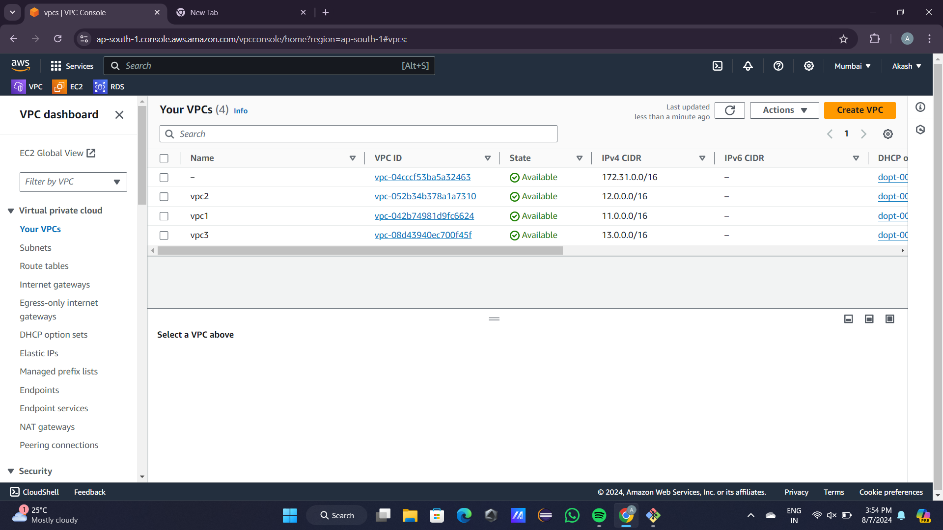

* After that we have to create internet gateway
* And attach these internet gateway to VPC’s

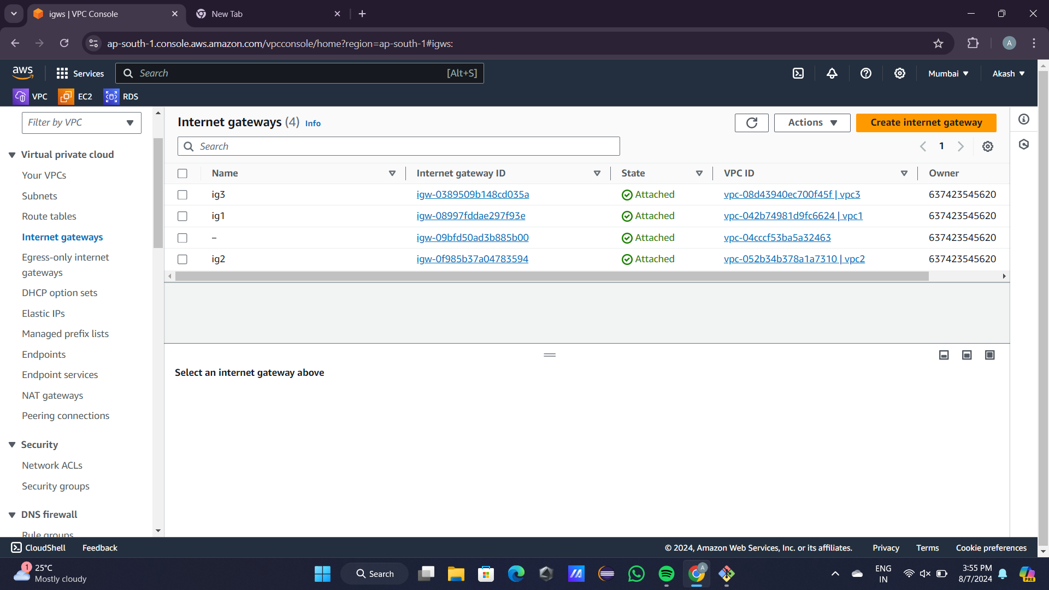

* Then we have to create 3 Subnets

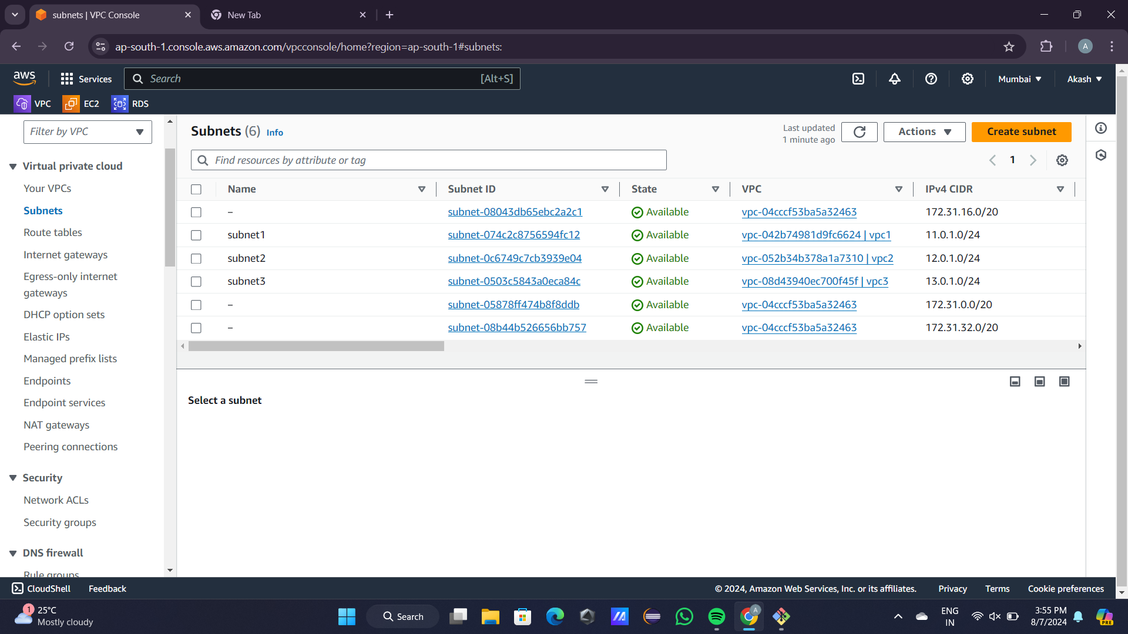

* After that we have to create 3 Route Table

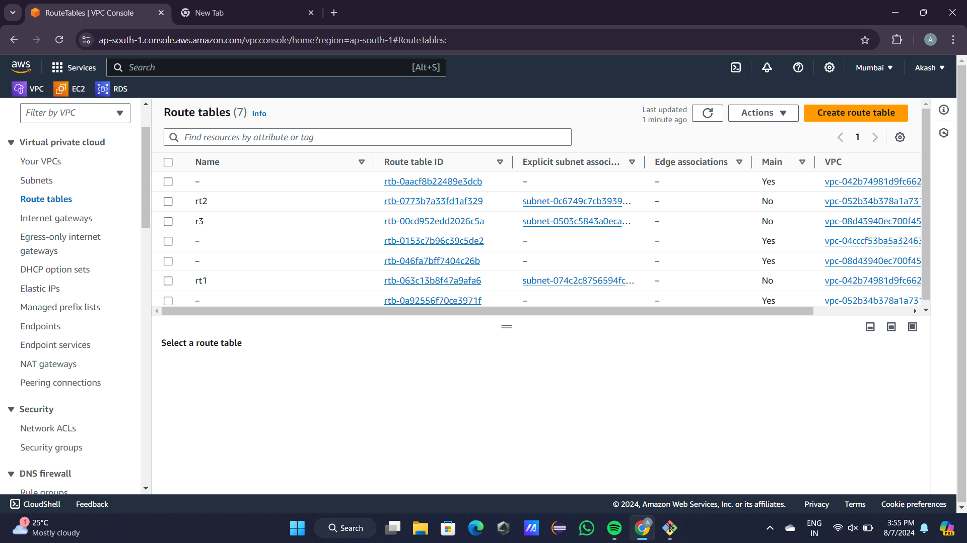

* In this Route Tables we have to edit Route

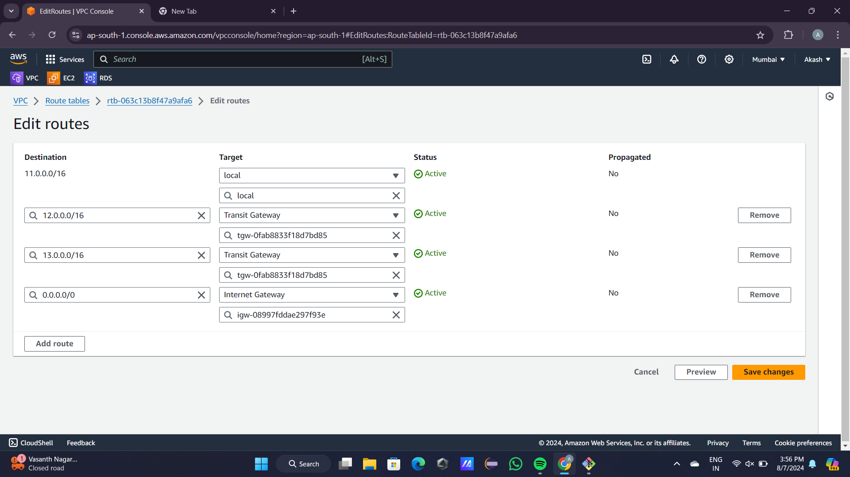

* After that we have to associate subnet

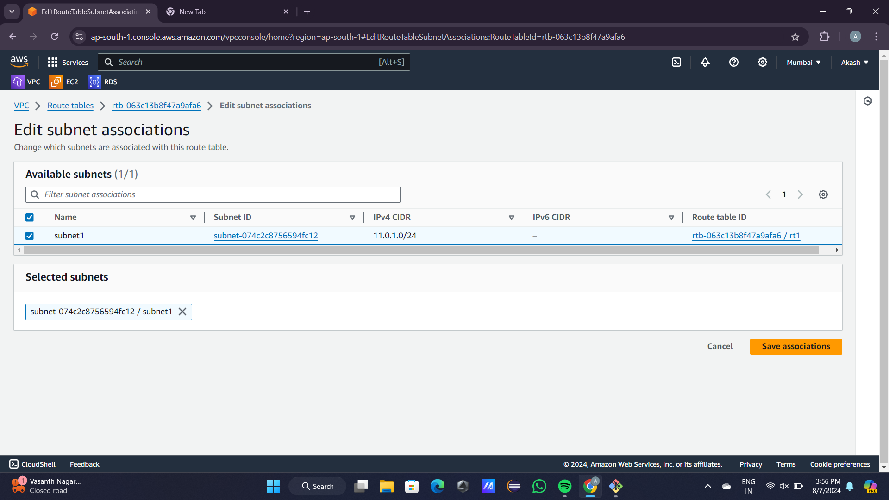

* After that we have to create 3 individual EC2 instances

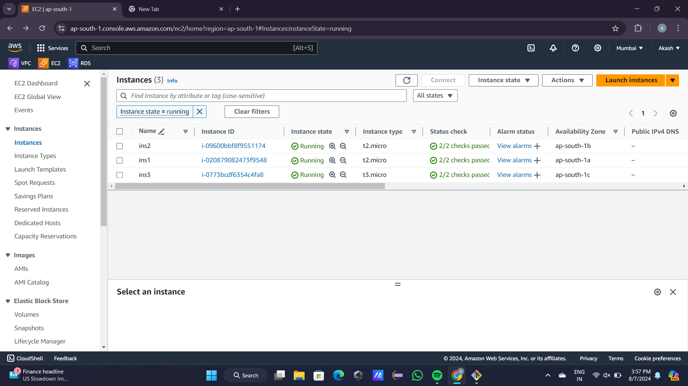

* Now, we have to create Transit Gateway and also Transit Gateway Attachments

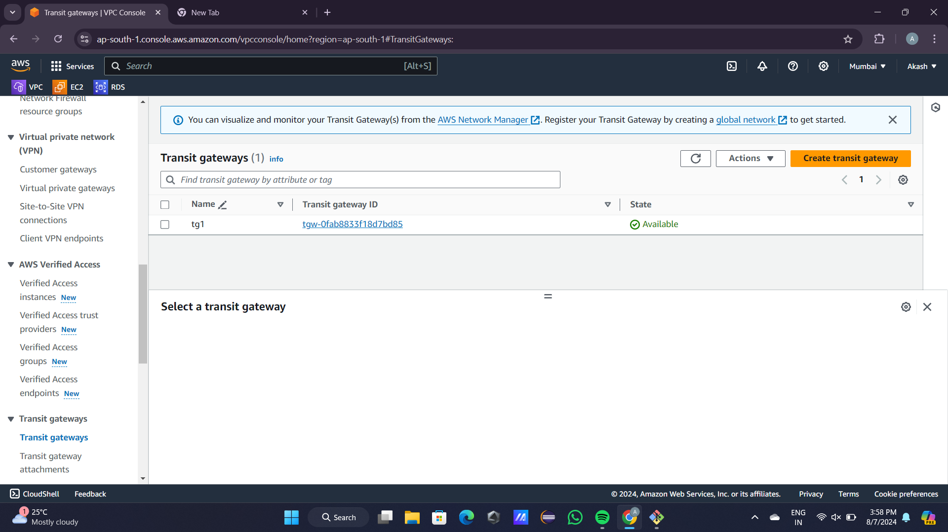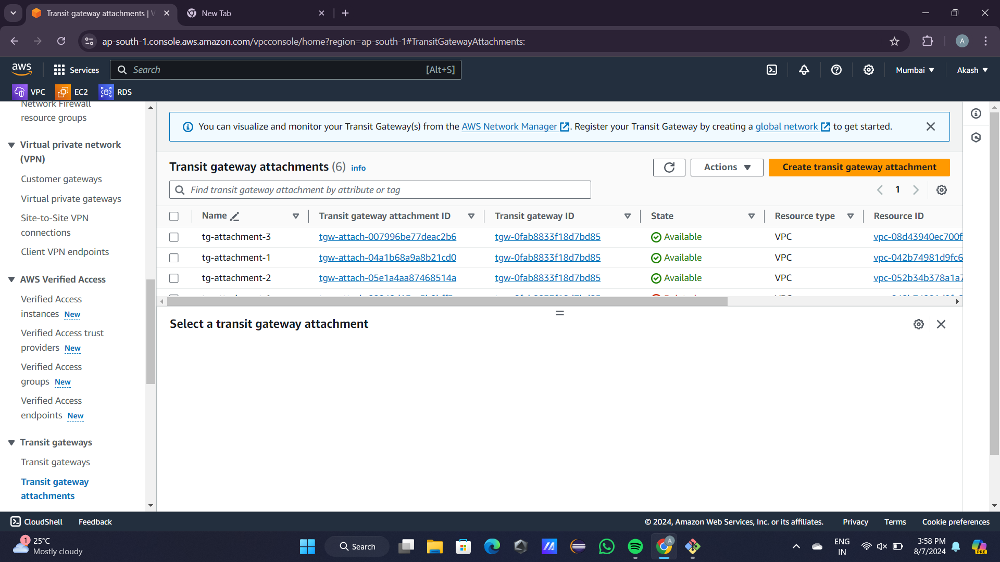

* Now, we have to connect instances

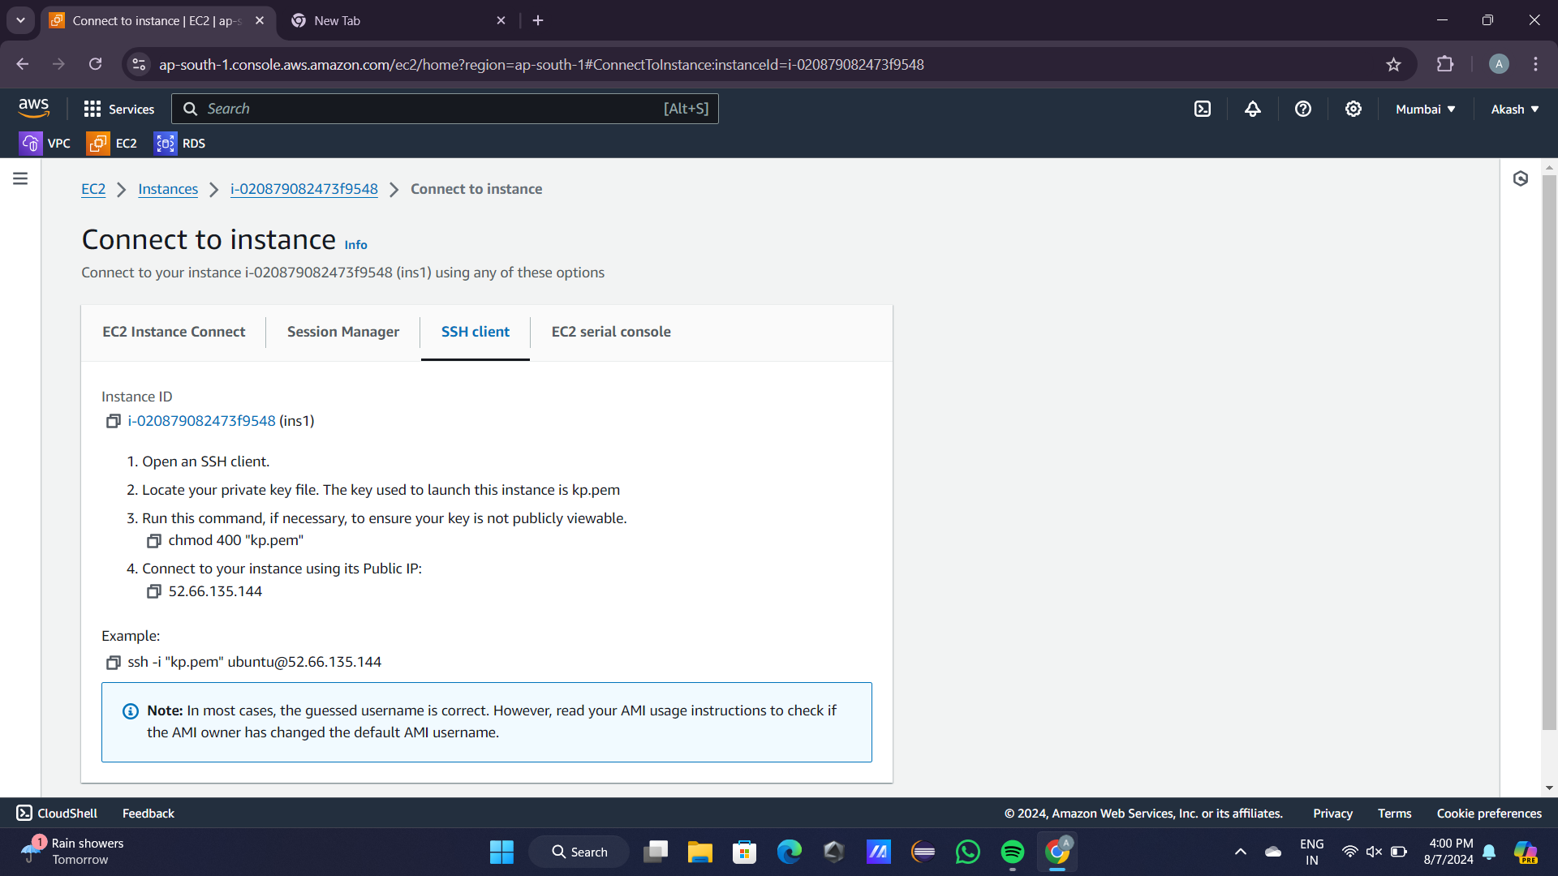

* After that we have to connect in Gitbash through the link in the above figure
* Use sudo -i command to become root user
* apt update -y && apt install nginx -y command for nginx installation
* Use ‘curl private address” to connect VPC’s

**Output:**

